# Summary

This readme file contains the detailed installation instructions for the FYP named SCE11-0353.

# Visual Studio 2010

* Download a free version at <https://www.dreamspark.com/Product/Product.aspx?productid=4>
* Run the installer and let it take care of the rest
* Download Visual Studio Service Pack 1 at <http://www.microsoft.com/en-us/download/details.aspx?id=23691>
* Run the service pack installer and let it take care of the rest
* Open the project as a web site, not a project
* After opening, please modify the following line of code in the global web.config file to the directory where project is located (screenshot provided)

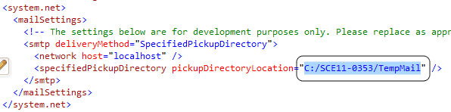

# SQL Server 2008 R2

* Download a free version at <https://www.dreamspark.com/Product/Product.aspx?productid=22>
* Run the installer
* Make sure SQL Server instance is set to Mixed Authentication Mode and has FileStream enabled (screenshots below)
* After installation, attach the database named ‘RIS_DB’ using SQL Server Management Studio to the SQL Server instance

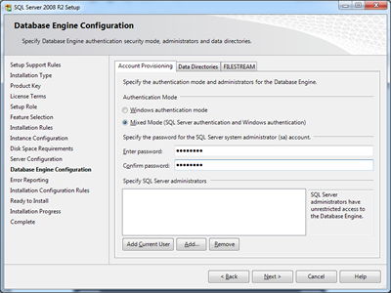

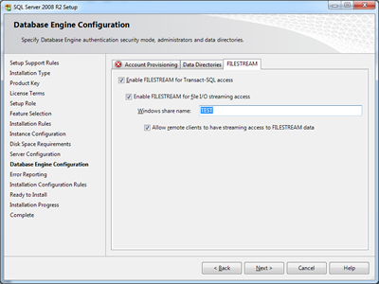

# Ajax Control Toolkit

* Download package via NuGet (screenshots below)

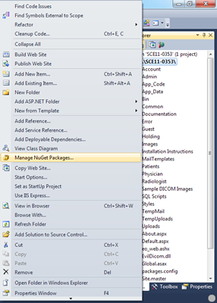

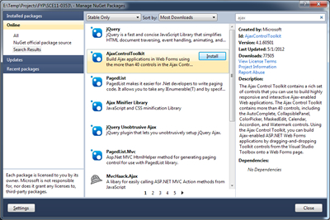

# EO.Web 2011 for ASP.NET

* Download installer at <http://www.essentialobjects.com/Download.aspx?p=EO.Web>
* Run the installer and it will take care of the rest

# Evil Dicom

* Download ‘EvilDicom.dll’ at <http://sourceforge.net/projects/evildicom/files/0.05.7/>
* Inside Visual Studio, reference the DLL (screenshots below)

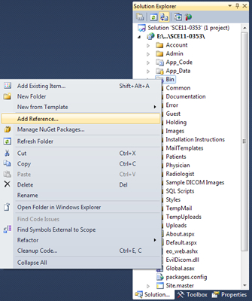

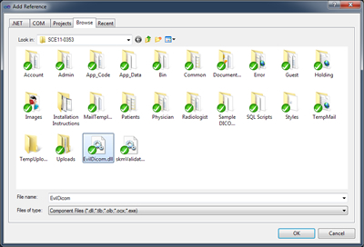

# Image Resizer

* Download package via NuGet (screenshots below)



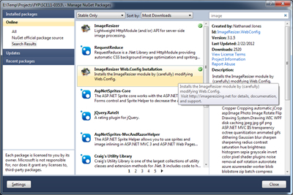

# skmValidators

* Download at <http://aspnet.4guysfromrolla.com/code/skmValidators.zip>, or <http://scottonwriting.net/sowblog/codeprojects.htm> under the ‘skmValidators’ heading
* Unzip the package and paste the file ‘skmValidators.dll’ into the project directory
* Inside Visual Studio, reference the DLL (screenshots below)



